AttenDex

AttenDex: Attendence Management System

Rugved Junghare, Prajakta Kumbhare, Pratik Mandalkar, Pratik Mane, Netra Mohekar

**Department of Information Technology, Vishwakarma Institute of Technology, Pune, 411037, Maharashtra, India**

Rugved Junghare, Prajakta Kumbhare, Pratik Mandalkar, Pratik Mane, Netra Mohekar

**Department of Information Technology, Vishwakarma Institute of Technology, Pune, 411037, Maharashtra, India**

# Abstract:

In modern educational and corporate landscapes, efficient attendance management plays a pivotal role in the success of organizations. Conventional manual methods of monitoring attendance exhibit shortcomings such as inaccuracies, time intensiveness, and a lack of actionable insights. These issues necessitate the creation of an advanced solution.

# Introduction:

The traditional methods of managing attendance suffer from inaccuracies and time-consuming processes. In educational and corporate settings, a more efficient system is required to monitor and manage attendance effectively. The "AttenDex" project aims to address these issues and provide a comprehensive solution for attendance management.

# Methodology:

The "AttenDex" Attendance Management System employs a structured methodology to efficiently manage attendance records of students or employees. This methodology revolves around data structures, algorithms, and a user-friendly interface, ensuring a comprehensive and user-centric approach to attendance management. Below are the key components of the methodology:

**1. Data Structure - Binary Search Tree (BST):**

* At the core of the AttenDex system is a Binary Search Tree (BST) data structure. A BST is utilized to organize, store, and manage attendance records efficiently. Each node of the BST represents an individual student or employee and contains essential information such as name, PRN (Personal Registration Number), days attended, and total lectures.

**2. Node Creation and Insertion:**

* The project begins with the creation of nodes representing individuals within the organization. A dedicated function, **createNode**, is responsible for allocating memory for a new node and initializing it with the individual's details.
* Nodes are then inserted into the BST using the **insertNode** function. The insertion process is based on the unique identifier, PRN. If the PRN of the individual is less than the current node's PRN, the node is inserted into the left subtree; otherwise, it is inserted into the right subtree.

**3. In-Depth Record Retrieval - Inorder Traversal:**

* The system facilitates the retrieval of records in a structured manner through inorder traversal of the BST. The **inorderTraversal** function traverses the BST and displays the records in an organized fashion. This enables users to access and review attendance information with ease.

**4. Warning Letter Generation:**

* An essential feature of AttenDex is the automated generation of warning letters for individuals with attendance below a specified threshold (e.g., 75%). This feature ensures that underperforming students or employees receive timely notifications, encouraging them to improve their attendance.

**5. Record Search by PRN:**

* AttenDex provides a search feature that allows users to locate specific records based on an individual's PRN. The **searchByPRN** function performs a search within the BST and returns the record matching the provided PRN, if found.

**6. Attendance Record Editing:**

* To accommodate updates or corrections to attendance records, the system allows authorized users to edit attendance information. The **editAttendance** function enables the modification of days attended, taking care to ensure that the input adheres to lecture limits and that attendance is only edited once for an individual.

**7. Attendance Statistics Calculation:**

* The project offers users valuable insights through the calculation of attendance statistics. The **displayStatistics** function determines the total number of students or employees, the cumulative attendance, and the average attendance percentage. This feature is vital for data-driven decision-making.

**8. User-Friendly Interface:**

* AttenDex is designed with a user-friendly interface to make it accessible to a wide range of users, including educators, administrators, HR personnel, and managers. The interface simplifies the process of attendance management and analysis, ensuring that users can navigate and utilize the system with ease.

**9. Security and Authentication:**

* To protect the integrity of attendance records, AttenDex incorporates user authentication, ensuring that only authorized individuals can access and modify attendance data.

This structured methodology, grounded in the principles of data structures and algorithms, transforms attendance management into a more accurate, efficient, and user-centric process. By implementing AttenDex, educational institutions and organizations can harness the power of technology to optimize their attendance tracking and enhance the quality of their services. The methodology is designed to address the inefficiencies and inaccuracies associated with traditional attendance management, ushering in an era where attendance monitoring is error-free and data-driven.

# Algorithm:

1. **Initialization:**
   * Start the system.
   * Initialize the Binary Search Tree (BST) root node as NULL.
   * Display the main menu.
2. **Main Menu:**
   * Present the main menu options:
     1. Admin Login
     2. Student Login
     3. Exit
   * Prompt the user for their choice.
3. **Admin Login:**
   * Prompt the admin for a username and password.
   * Validate the credentials:
     1. If valid, proceed to admin menu.
     2. If invalid (three attempts allowed), deny access.
   * If access is denied three times, exit the system.
4. **Student Login:**
   * Prompt the user for a PRN (Personal Registration Number).
   * Search for the student/employee record using the PRN.
   * Display the record (if found) or show a "not found" message.
5. **Admin Menu (Post-Login):**
   * After completing admin or student tasks, return to the admin menu.
   * Loop back to Step 2 (Main Menu).
6. **Admin Menu Functions (BST Operations):**
   * Create a new node:
     1. Allocate memory for a new node.
     2. Initialize the node with provided information.
     3. Insert the node into the BST.
   * Display attendance records:
     1. Traverse the BST in-order.
     2. Display the records in an organized manner.
   * Generate warning letters:
     1. Traverse the BST to identify records with low attendance.
     2. Generate warning letters for individuals below the attendance threshold.
   * Search for a record by PRN:
     1. Search for a record by PRN within the BST.
     2. Return the matching record (if found).
   * Edit attendance:
     1. Edit the attendance record for a specific PRN.
     2. Validate input and ensure it doesn't exceed lecture limits.
   * Display attendance statistics:
     1. Calculate and display attendance statistics, including total students/employees, total attendance, and average attendance.
7. **User-Friendly Interface:**
   * The system is designed with a user-friendly interface.
   * It ensures that authorized users can navigate and use the system with ease.
8. **Security and Authentication:**
   * User authentication is implemented to secure attendance records.
   * Only authorized individuals can access and modify attendance data.
9. **Exit the System:**
   * Terminate the system when the user chooses to exit.

# Pseudo-Code:

# Initialize an empty Binary Search Tree (BST)

BST root = NULL

# Main Menu Loop

while true:

    Display Main Menu Options:

    1. Admin Login

    2. Student Login

    0. Exit

    Input choice

    if choice is 1:

        Admin Login:

        Attempt = 3

        while Attempt > 0:

            Input username, password

            if username and password are correct:

                Call adminMenu()

                Exit

            else:

                Decrement Attempt

        Display "Access Denied"

    else if choice is 2:

        Student Login:

        Input PRN

        Find student in the BST by PRN

        Display the student's attendance (if found)

    else if choice is 0:

        Exit the program

# Admin Menu Loop

function adminMenu():

    while true:

        Display Admin Menu Options:

        1. Add Student

        2. Display Attendance

        3. Create Data File

        4. Generate Warning Letters

        5. Search by PRN

        6. Edit Attendance

        7. Display Statistics

        8. Exit

        Input choice

        if choice is 1:

            Input student details

            Insert the student into the BST

        else if choice is 2:

            Display attendance records using in-order traversal

        else if choice is 3:

            Create a data file and write records to it

        else if choice is 4:

            Generate warning letters for students with low attendance

        else if choice is 5:

            Input PRN to search

            Find student by PRN in the BST

            Display the student's attendance (if found)

        else if choice is 6:

            Input PRN to edit attendance

            Input newDaysAttended

            Edit attendance (if valid)

        else if choice is 7:

            Calculate and display attendance statistics

        else if choice is 8:

            Exit adminMenu

# Flowchart:

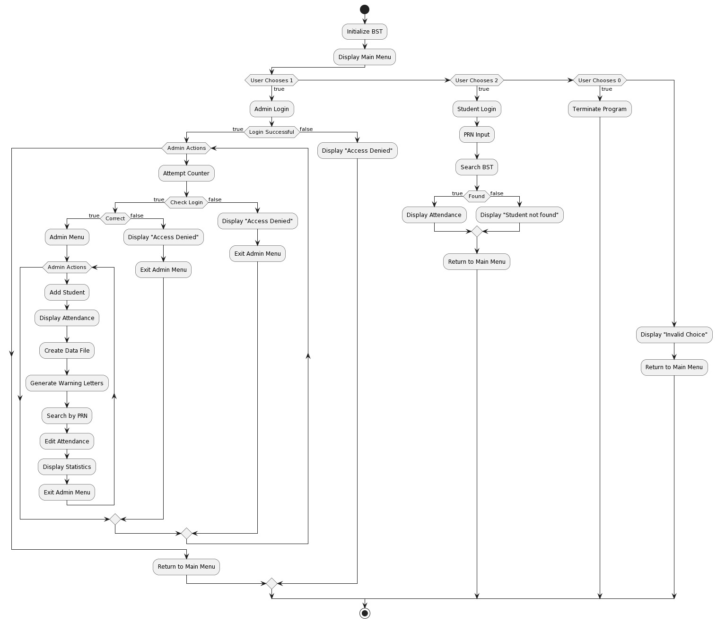

# Data Structure Used: BST

1. **Node Structure:** Each node in the BST stores information about a student's attendance. The node structure in your project includes fields like name, PRN (Personal Registration Number), days attended, attendance percentage, and pointers to left and right child nodes.
2. **Organization:** The BST is organized based on the PRN of the students. Nodes with smaller PRNs are placed to the left of the parent node, while nodes with larger PRNs are placed to the right. This organization allows for efficient searching and retrieval of student records based on PRN.
3. **Searching:** The BST structure is particularly useful for searching for students by their PRN. When you want to find a student's attendance record, the BST allows for relatively quick access to the relevant node by navigating through the tree based on the PRN.
4. **Insertion:** When you add a new student's attendance record, the BST is used to insert the record in the correct position within the tree based on the student's PRN. This insertion process ensures that the tree remains balanced.
5. **In-Order Traversal:** To display the attendance records, the project uses in-order traversal of the BST. This traversal method visits nodes in ascending order of PRN, making it easy to list students' attendance records in a sorted manner.
6. **Edit and Update:** If you need to edit a student's attendance, the BST is used to search for the specific student by PRN and then update their attendance information efficiently.
7. **Data File Generation:** The BST can be used to generate a data file that stores the attendance records in a structured manner. By performing an in-order traversal of the tree and writing the records to a file, you can create a data file with the information.

# Results:

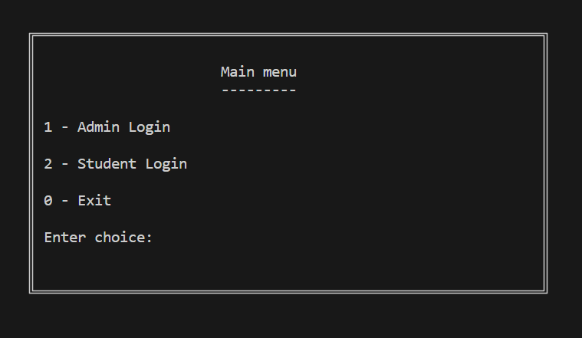

Fig 1. Main Menu

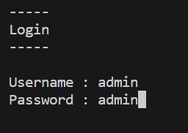

Fig 2. Login

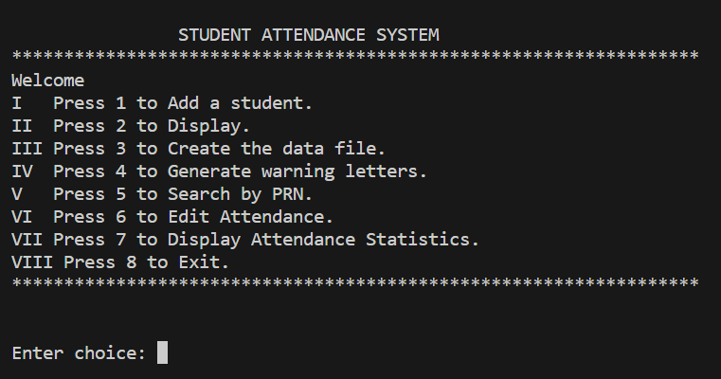

Fig 3. Menu Driven Interface

ig 3. Menu Driven Interface

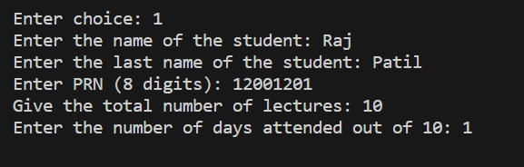

Fig 4. Add Student

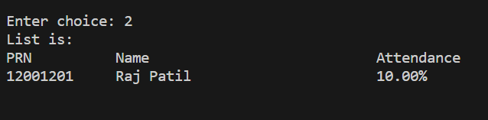

Fig 5. Display

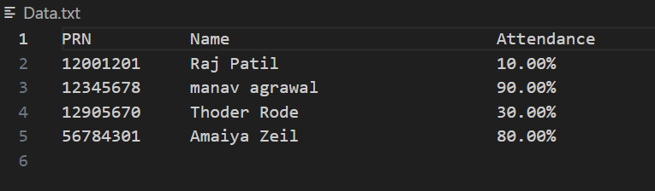

Fig 6. Display Data.txt file

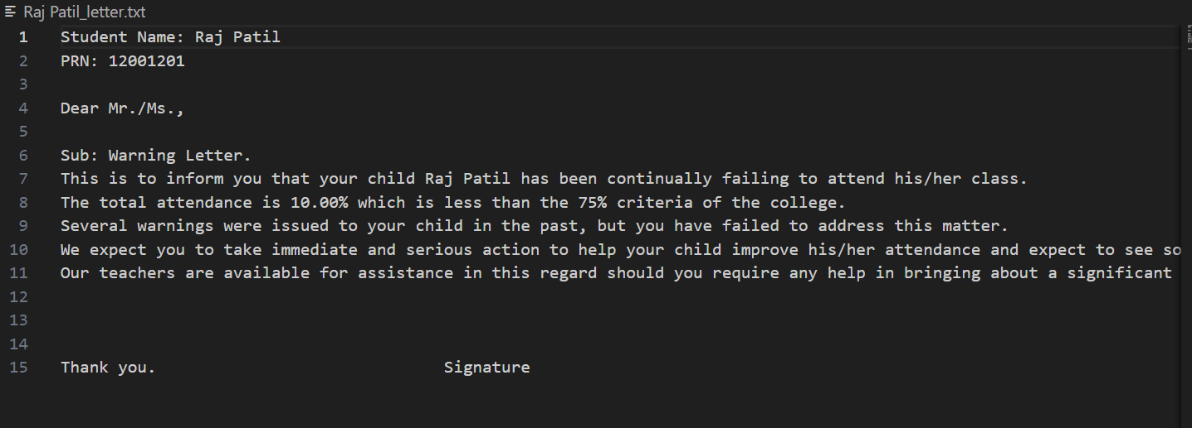

Fig 7. Generating Warning Letter

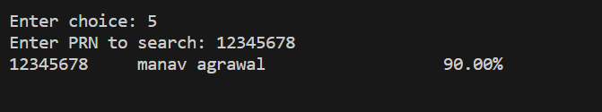

Fig 8. Search by PRN

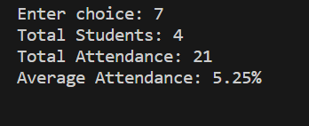

Fig 9. Attendance Stats

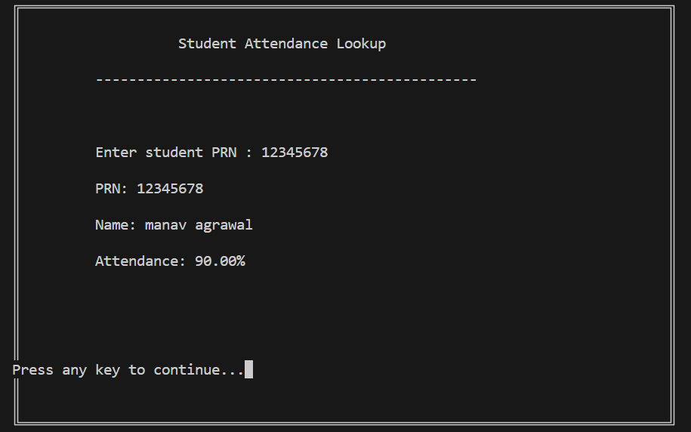

Fig 10. Student Login

# Conclusion:

The AttenDex project represents a comprehensive and efficient solution for attendance management in educational and corporate settings. This system addresses the limitations of manual attendance tracking by offering a user-friendly and automated approach. Here are the key takeaways and conclusions:

1. **Efficiency and Accuracy:** AttenDex significantly improves the efficiency of attendance management. The Binary Search Tree (BST) data structure allows for quick and accurate access to attendance records based on the student's PRN. This results in reduced manual effort and minimized errors.
2. **User-Centric Design:** The project is designed with the end-users in mind. It provides both administrative and student login options, making it accessible and relevant for all stakeholders. Admins can efficiently manage attendance records, generate reports, and send warning letters, while students can easily access their own attendance data.
3. **Data File Generation:** AttenDex offers a feature to create a structured data file. This data file can serve as an essential record for auditing and analysis, making it easier for educational institutions and organizations to manage their attendance data.
4. **Proactive Intervention:** The system generates warning letters for students with low attendance percentages, enabling educational institutions to take proactive measures to improve attendance rates and student performance.
5. **Statistical Insights:** The system provides statistical insights by calculating and displaying attendance statistics. This information can assist administrators in making informed decisions and evaluating the effectiveness of attendance management efforts.
6. **Security Measures:** The project incorporates security measures, such as login attempts limits, to protect the system from unauthorized access, ensuring the confidentiality and integrity of attendance data.

In conclusion, the AttenDex - Attendance Management System offers a modern and efficient solution to the challenges of attendance tracking in educational and corporate environments. By automating processes, providing data-driven insights, and ensuring data security, it empowers institutions and organizations to manage attendance effectively, resulting in improved educational outcomes and operational efficiency.

# References:

* A Binary Search Tree Based Attendance Management System: https://iq.opengenus.org/time-and-space-complexity-of-binary-search-tree/
* Design and Implementation of an Attendance Management System Using Binary Search Tree: https://samphina.com.ng/design-implementation-attendance-management-system/
* Performance Evaluation of Attendance Management Systems Using Binary Search Tree: https://www.researchgate.net/publication/333340499_Performance_Evaluation_and_Analysis_of_Biometric_Workload_Attendance_Performance_Evaluation_and_Analysis_of_Biometric_Workload_Attendance_Performance_Evaluation_and_Analysis_of_Biometric_Workload_Atte
* A Comparison of Different Data Structures for Attendance Management Systems: https://www.researchgate.net/figure/COMPARISON-ON-VARIOUS-ATTENDANCE-MANAGEMENT-SYSTEM_tbl1_340940630
* Security and Privacy Considerations for Attendance Management Systems: https://www.spiceworks.com/hr/workforce-management/articles/features-of-attendance-management-systems/